Kubernetes Activity4-

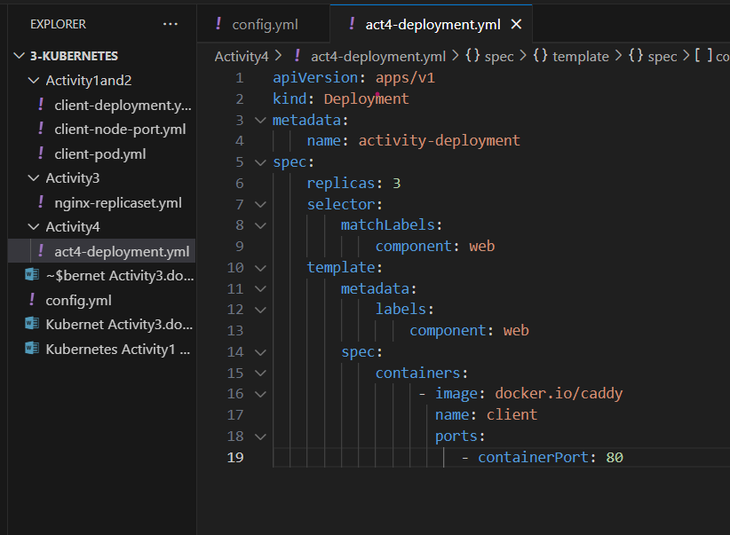

# Create a deployment that manages 3 replicas of caddy.

$ kubectl apply -f act4-deployment.yml

# Verify that the deployment created the pods.

$ kubectl describe deployment activity-deployment



